Debre markos Institute of Technology
School of Computing
computer science Academic program

Computer Graphics

Chapter 2 Handout – Graphics Primitives

Introduction

All graphics packages construct pictures from basic building blocks known as graphics primitives. Primitives that describe the geometry, or shape, of these building blocks are known as geometric primitives. They can be anything from 2-D primitives such as points, lines and polygons to more complex 3-D primitives such as spheres and polyhedra (a polyhedron is a 3-D surface made from a mesh of 2-D polygons).

In the following sections we will examine some algorithms for drawing different primitives, and where appropriate we will introduce the routines for displaying these primitives in OpenGL.

OpenGL Point Drawing Primitives

The most basic type of primitive is the point. Many graphics packages, including OpenGL, provide routines for displaying points. To recap, we use the pair of functions glBegin … glEnd, using the symbolic constant GL_POINTS to specify how the vertices in between should be interpreted. In addition,
- the function glPointSize can be used to set the size of the points in pixels.
- The default point size is 1 pixel.
- Points that have a size greater than one pixel are drawn as squares with a side length equal to their size.
For example, the following code draws three 2-D points with a size of 2 pixels.

glPointSize(2.0);
glBegin(GL_POINTS);
glVertex2f(100.0, 200.0);
glVertex2f(150.0, 200.0);
glVertex2f(150.0, 250.0);
glEnd();

Note that when we specify 2-D points, OpenGL will actually create 3-D points with the third coordinate (the z-coordinate) equal to zero. Therefore, there is not really any such thing as 2-D graphics in OpenGL – but we can simulate 2-D graphics by using a constant z-coordinate.

Line Drawing Algorithms

Lines are a very common primitive and will be supported by almost all graphics packages. In addition, lines form the basis of more complex primitives such as polylines (a connected sequence of straight-line segments) or polygons (2-D objects formed by straight-line edges).
Lines are normally represented by the two end-points of the line, and points (x ,y) along the line must satisfy the following slope-intercept equation:

y = mx + c …………………………………………………………………… (1)

where m is the slope or gradient of the line, and c is the coordinate at which the line intercepts the y-axis. Given two end-points (x₀,y₀) and (x_{end},y_{end}), we can calculate values for m and c as follows:
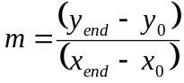 …………………………………………………………… (2)
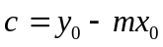 …………………………………………………………………… (3)

Furthermore, for any given x-interval δx, we can calculate the corresponding y-interval δy:
δy = m.δx …………………………………………………………………… (4)
δx = 1 / δy …………………………………………………………………… (5)

These equations form the basis of the two line-drawing algorithms described below: the DDA algorithm and Bresenham’s algorithm.

DDA Line-Drawing Algorithm

The Digital Differential Analyser (DDA) algorithm operates by starting at one end-point of the line, and then using Eqs. (4) and (5) to generate successive pixels until the second end-point is reached. Therefore, first, we need to assign values for δx and δy.
Before we consider the actual DDA algorithm, let us consider a simple first approach to this problem. Suppose we simply increment the value of x at each iteration (i.e. δx = 1), and then compute the corresponding value for y using Eqs. (2) and (4). This would compute correct line points but, as illustrated by Figure 1, it would leave gaps in the line. The reason for this is that the value of δy is greater than one, so the gap between subsequent points in the line is greater than 1 pixel.
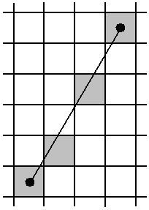

Figure 1 – ‘Holes’ in a Line Drawn by Incrementing x and Computing the Corresponding y-Coordinate

The solution to this problem is to make sure that both δx and δy have values less than or equal to one. To ensure this, we must first check the size of the line gradient. The conditions are:
- If |m| ≤ 1:
  - δx = 1
  - δy = m
- If |m| > 1:
  - δx = 1/m
  - δy = 1
Once we have computed values for δx and δy, the basic DDA algorithm is:
- Start with (x₀,y₀)
- Find successive pixel positions by adding on (δx, δy) and rounding to the nearest integer, i.e.
  - x_{k+1} = x_{k} + δx
  - y_{k+1} = y_{k} + δy
- For each position (x_{k},y_{k}) computed, plot a line point at (round(x_{k}),round(y_{k})), where the round function will round to the nearest integer.

Note that the actual pixel value used will be calculated by rounding to the nearest integer, but we keep the real-valued location for calculating the next pixel position.

Let us consider an example of applying the DDA algorithm for drawing a straight-line segment. Referring to see Figure 2, we first compute a value for the gradient m:

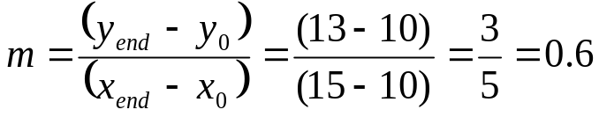

Now, because |m| ≤ 1, we compute δx and δy as follows:

δx = 1
δy = 0.6

Using these values of δx and δy we can now start to plot line points:
- Start with (x₀,y₀) = (10,10) – colour this pixel
- Next, (x₁,y₁) = (10+1,10+0.6) = (11,10.6) – so we colour pixel (11,11)
- Next, (x₂,y₂) = (11+1,10.6+0.6) = (12,11.2) – so we colour pixel (12,11)
- Next, (x₃,y₃) = (12+1,11.2+0.6) = (13,11.8) – so we colour pixel (13,12)
- Next, (x₄,y₄) = (13+1,11.8+0.6) = (14,12.4) – so we colour pixel (14,12)
- Next, (x₅,y₅) = (14+1,12.4+0.6) = (15,13) – so we colour pixel (15,13)
- We have now reached the end-point (x_{end},y_{end}), so the algorithm terminates

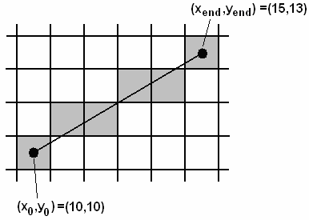

Figure 2 - The Operation of the DDA Line-Drawing Algorithm

The DDA algorithm is simple and easy to implement, but it does involve floating point operations to calculate each new point. Floating point operations are time-consuming when compared to integer operations. Since line-drawing is a very common operation in computer graphics, it would be nice if we could devise a faster algorithm which uses integer operations only. The next section describes such an algorithm.

OpenGL Line Functions

We can draw straight-lines in OpenGL using the same glBegin … glEnd functions that we saw for point-drawing. This time we specify that vertices should be interpreted as line end-points by using the symbolic constant GL_LINES. For example, the following code

glLineWidth(3.0);
glBegin(GL_LINES);
glVertex2f(100.0, 200.0);
glVertex2f(150.0, 200.0);
glVertex2f(150.0, 250.0);
glVertex2f(200.0, 250.0);
glEnd()

will draw two separate line segments: one from (100,200) to (150,200) and one from (150,250) to (200,250). The line will be drawn in the current drawing colour and with a width defined by the argument of the function glLineWidth.

Two other symbolic constants allow us to draw slightly different types of straight-line primitive: GL_LINE_STRIP and GL_LINE_LOOP. The following example illustrates the difference between the three types of line primitive. First we define 5 points as arrays of 2 Glint values. Next, we define exactly the same vertices for each of the three types of line primitive. The images to the right show how the vertices will be interpreted by each primitive.

Glint p1[] = {200,100}; Glint p2[] = {50,0}
Glint p3[] = {100,200}; Glint p4[] = {150,0};
Glint p5[] = {0,100};
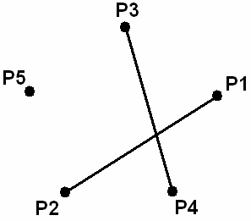
glBegin(GL_LINES);
glVertex2iv(p1);
glVertex2iv(p2);
glVertex2iv(p3);
glVertex2iv(p4);
glVertex2iv(p5);
glEnd();
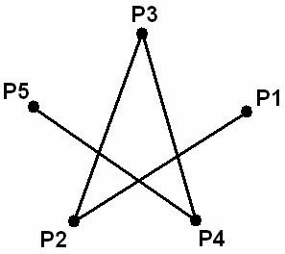
glBegin(GL_LINE_STRIP);
glVertex2iv(p1);
glVertex2iv(p2);
glVertex2iv(p3);
glVertex2iv(p4);
glVertex2iv(p5);
glEnd();
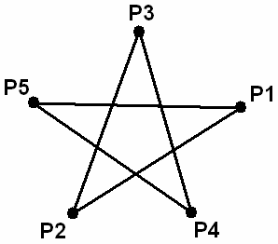
glBegin(GL_LINE_LOOP);
glVertex2iv(p1);
glVertex2iv(p2);
glVertex2iv(p3);
glVertex2iv(p4);
glVertex2iv(p5);
glEnd();
We can see that GL_LINES treats the vertices as pairs of end-points. Lines are drawn separately and any extra vertices (i.e. a start-point with no end-point) are ignored. GL_LINE_STRIP will create a connected polyline, in which each vertex is joined to the one before it and after it. The first and last vertices are only joined to one other vertex. Finally, GL_LINE_LOOP is the same as GL_LINE_STRIP except that the last point is joined to the first one to create a loop.

Circle-Drawing Algorithms
Drawing a circle on the screen is a little complex than drawing a line. There are two popular algorithms for generating a circle − Bresenham’s Algorithm and Midpoint Circle Algorithm. These algorithms are based on the idea of determining the subsequent points required to draw the circle. Let us discuss the algorithms in detail
The equation of circle is X²+Y²=r^{2 , X2}+Y²=r², where r is radius.
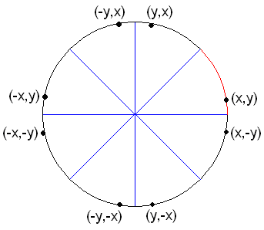

Figure Four-Way Symmetry of Circles

Midpoint Circle-Drawing Algorithm

The circle diagram we can divide a circle into eight different octants for the symmetry if we draw only one octane we ca easily draw points on other seven octants using reflection procedure.
Here we have to find points for the first octant, when x ≥ y then it indicates the end of octants 1
The first coordinate point is (0, r) to draw the circle, the x increasing as unit interval the y decreasing along the values of x
The next point be either (x_{k}+1, y_{k}-1) or (x_{k}+1, y_{k}), so the midpoint of those two points are (x_{M}, y_{m}) where
x_{m=}(x_{k}+1 + x_{k}+1)/2
y_{m} = (y_{k}-1+y_{k})/2
(x_{M}, y_{m})= (xk+1, yk-¹/₂)
The midpoint algorithm is illustrated in Figure 3. Recall that we only need to draw one octant of the circle, as the other seven octants can be generated by symmetry. In Figure 3 we are drawing the right-hand upper octant – the one with coordinate (y,x) in Error: Reference source not found, but the midpoint algorithm would work with slight modifications whichever octant we chose. Notice that in this octant, when we move from one pixel to try to draw the next pixel there is only a choice of two pixels: A and B, or (x_{k+1},y_{k}) and (x_{k+1},y_{k-1}). Therefore, we don’t need to calculate a real-valued coordinate and then round to the nearest pixel, we just need to make a decision as to which of the two pixels to choose.
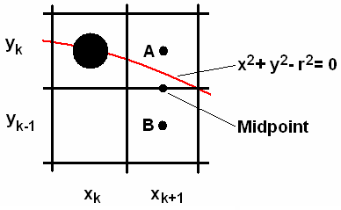

Figure 3 - The Midpoint Circle-Drawing Algorithm

We start by defining a function f_{circ} as follows:

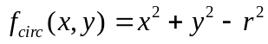 ………………………………………………….. (6)

This term can be derived directly from Eq. (14). Based on the result of this function, we can determine the position of any point relative to the circle boundary:
- For points on circle, f_{circ}= 0
- For points inside circle, f_{circ}< 0
- For points outside circle, f_{circ}> 0

Now referring again to Figure 3, we note that the position of the midpoint of the two pixels A and B can be written as:

mid_{k} = (x_{k}+1,y_{k}-0.5) ………………………………………………………….. (7)

Now we can see from Figure 3 that if the midpoint lies inside the circle boundary the next pixel to be plotted should be pixel A. Otherwise it should be pixel B. Therefore, we can use the value of f_{circ}(mid_{k}) to make the decision between the two candidate pixels:
- If f_{circ}(mid_{k}) < 0, choose A
- Otherwise choose B

In order to make this decision quickly and efficiently, we define a decision variable p_{k}, by combining Eqs. (6) and (7):

………………….. (8)

An incremental calculation for p_{k+1} can be derived by subtracting p_{k} from p_{k+1} and simplifying – the result is:

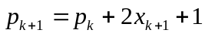, if p_{k} < 0 …………………………………………… (9)
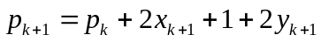, if p_{k} ≥ 0 …………………………………… (10)
The initial value of the decision variable, p₀, is calculated by evaluating it at the starting point (0,r):

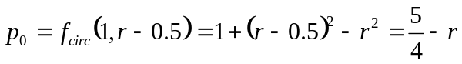. …………………………… (11)

If r is an integer, then all increments are integers and we can round Eq. (11) to the nearest integer:

p₀ = 1 – r …………………………………………………………………… (12)

Summary

To summarise, we can express the midpoint circle-drawing algorithm for a circle centred at the origin as follows:
- Plot the start-point of the circle (x₀,y₀) = (0,r)
- Compute the first decision variable:
  - 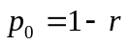
- For each k, starting with k=0:
  - If p_{k} < 0:
    - Plot (x_{k}+1,y_{k})
  - Otherwise:
    - Plot (x_{k}+1,y_{k}-1)
    - 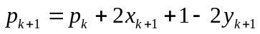

Example

For example, given a circle of radius r=10, centred at the origin, the steps are:
- First, compute the initial decision variable:
  - 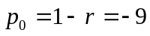
- Plot (x₀,y₀) = (0,r) = (0,10)
- Iteration 0:
  - p₀ < 0, so
    - Plot (x₁,y₁) = (x₀+1,y₀) = (1,10)
    - 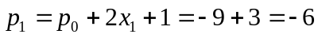
- Iteration 1:
  - p₁ < 0, so
    - Plot (x₂,y₂) = (x₁+1,y₁) = (2,10)
    - 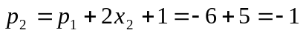
- Iteration 2:
  - p₂ < 0, so
    - Plot (x₃,y₃) = (x₂+1,y₂) = (3,10)
    - 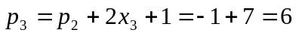
- Iteration 3:
  - p₃ ≥ 0, so
    - Plot (x₄,y₄) = (x₃+1,y₃-1) = (4,9)
    - 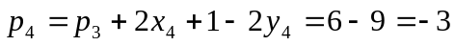
- Iteration 4:
  - p₄ < 0, so
    - Plot (x₅,y₅) = (x₄+1,y₄) = (5,9)
    - 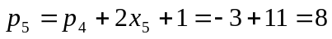
- Iteration 5:
  - p₅ ≥ 0, so
    - Plot (x₆,y₆) = (x₅+1,y₅-1) = (6,8)
    - 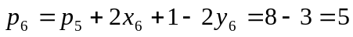
- Etc.

Ellipse-Drawing Algorithms

Some graphics packages may provide routines for drawing ellipses, although as we will see ellipses cannot be drawn as efficiently as circles. The equation for a 2-D ellipse in Cartesian coordinates is:

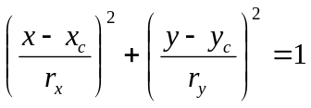 …………………………………………………… (13)

Alternatively, in polar coordinates, we can write:

x = x_{c} + r_{x} cos θ …………………………………………………………… (14)
y = y_{c} + r_{y} sin θ …………………………………………………………… (15)

To understand these equations, refer to Figure 4. Notice that Eqs. (13)-(27) are similar to the circle equations given in Eqs. 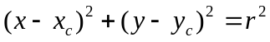- 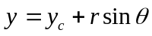, except that ellipses have two radius parameters: r_{x} and r_{y}. The long axis (in this case, r_{x}) is known as the major axis of the ellipse; the short axis (in this case r_{y}) is known as the minor axis. The ratio of the major to the minor axis lengths is called the eccentricity of the ellipse.

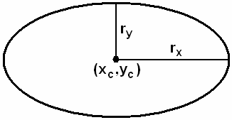

Figure 4 - Ellipse Drawing

The Midpoint Algorithm for Ellipse Drawing

The most efficient algorithm for drawing ellipses is an adaptation of the midpoint algorithm for circle-drawing. Recall that in the midpoint algorithm for circles we first had to define a term whose sign indicates whether a point is inside or outside the circle boundary, and then we applied it to the midpoint of the two candidate pixels. For ellipses, we define the function f_{ellipse} as:

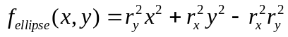 ………………………………………….. (16)

Eq. (16) can be derived from Eq. (13) by assuming that (x_{c},y_{c}) = (0,0), and then multiplying both sides by 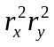. Now we can say the same for f_{ellipse} as we did for the circle function:
- For points on ellipse f_{ellipse}= 0
- For points inside ellipse f_{ellipse}< 0
- For points outside ellipse f_{ellipse}> 0

But at this point we have a slight problem. For circles there was 4-way symmetry so we only needed to draw a single octant. This meant we always had a choice of just 2 pixels to plot at each iteration. But ellipses only have 2-way symmetry, which means we have to draw an entire quadrant (see Figure 5).

Therefore the midpoint algorithm for ellipses is:
- At each point, compute gradient m:
  - If |m| ≤ 1 we increment x and decide between candidate y positions
  - If |m| >1 we increment y and decide between candidate x positions

Again, a fast incremental algorithm exists to compute a decision function, but because of the gradient calculation the midpoint ellipse-drawing algorithm is not as efficient as the midpoint circle drawing algorithm.

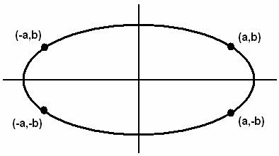

Figure 5 - Two-Way Symmetry of Ellipses

Fill-Area Primitives

The most common type of primitive in 3-D computer graphics is the fill-area primitive. The term fill-area primitive refers to any enclosed boundary that can be filled with a solid colour or pattern. However, fill-area primitives are normally polygons, as they can be filled more efficiently by graphics packages. Polygons are 2-D shapes whose boundary is formed by any number of connected straight-line segments. They can be defined by three or more coplanar vertices (coplanar points are positioned on the same plane). Each pair of adjacent vertices is connected in sequence by edges. Normally polygons should have no edge crossings: in this case they are known as simple polygons or standard polygons (see Figure 6).

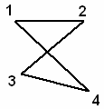

Figure 6 - A Polygon with an Edge Crossing

Polygons are the most common form of graphics primitive because they form the basis of polygonal meshes, which is the most common representation for 3-D graphics objects. Polygonal meshes approximate curved surfaces by forming a mesh of simple polygons. Some examples of polygonal meshes are shown in Figure 7.

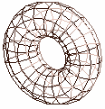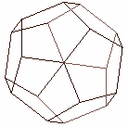
Mid exam covers up to this content GO back
Figure 7 - Examples of Polygonal Mesh Surfaces

Convex and Concave Polygons

We can differentiate between convex and concave polygons:
- Convex polygons have all interior angles ≤ 180º
- Concave polygons have at least one interior angle > 180º
The difference between convex and concave polygons is shown in Figure 8. Many graphics packages (including OpenGL) require all fill-area polygons to be convex polygons. The reason for this, as we will see in Chapter 3, is that it is much more efficient to fill a polygon if we know it is convex. Some packages even require that all fill-area primitives are triangles, as this makes filling even more straightforward.

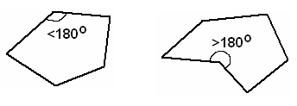
(a) (b)

Figure 8 – Types of Polygon: (a) Convex; (b) Concave

Most graphics packages also insist on some other conditions regarding polygons. Polygons may not be displayed properly if any of the following conditions are met:
- The polygon has less than 3 vertices; or
- The polygon has collinear vertices; or
- The polygon has non-coplanar vertices; or
- The polygon has repeated vertices.
Polygons that meet one of these conditions are often referred to as degenerate polygons. Degenerate polygons may not be displayed properly by graphics packages, but many packages (including OpenGL) will not check for degenerate polygons as this takes extra processing time which would slow down the rendering process. Therefore it is up to the programmer to make sure that no degenerate polygons are specified.

How can we identify if a given polygon is convex? A number of approaches exist:
- Compute and check all interior angles – if one is greater than 180º then the polygon is concave; otherwise it is convex.
- Infinitely extend each edge, and check for an intersection of the infinitely extended edge with other edges in the polygon. If any intersections exist for any edge, the polygon is concave; otherwise it is convex.
- Compute the cross-product of each pair of adjacent edges. If all cross-products have the same sign for their z-coordinate (i.e. they point in the same direction away from the plane of the polygon), then the polygon is convex; otherwise it is concave.

The last technique used the cross-product of vectors. The result of the cross-product of two vectors is a vector perpendicular to both vectors, whose magnitude is the product of the two vector magnitudes multiplied by the sin of the angle between them:

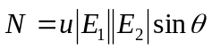, where 0 ≤ θ ≤ 180º …………………………………… (17)

Absolut values | |
The direction of the cross-product is determined by the right-hand rule:
- For V1xV2, with your right-hand grasp an axis that is perpendicular to V1 and V2, so that the fingers curl from V1 to V2 forming an angle <180º. The direction of the cross-product is the direction of your right thumb.
This is illustrated in Figure 9. If you imagine V1 pointing along the x-axis and V2 pointing along the y-axis, then the z-axis is the direction of the cross-product. This is true so long as the angle between V1 and V2 is less than 180º. If it becomes greater than 180º, then we would need to switch V1 and V2 (i.e. V1 is the y-axis and V2 the x-axis), so that the angle between them became less than 180º again. In this case the cross-product would point in the opposite direction.

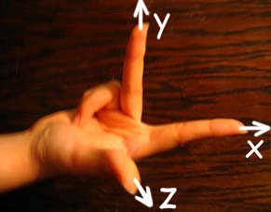

Figure 9 - The Right-Hand Rule for Computing Cross-Products

Splitting Concave Polygons

Because most graphics packages insist on polygons being convex, once we have identified concave polygons we need to split them up to create a number of convex polygons.

One technique for splitting concave polygons is known as the vector technique. This is illustrated in Figure 10, and can be summarised as follows:
- Compute the cross-product of each pair of adjacent edge vectors.
- When the cross-product of one pair has a different sign for its z-coordinate compared to the others (i.e. it points in the opposite direction):
  - Extend the first edge of the pair until it intersects with another edge.
  - Form a new vertex at the intersection point and split the polygon into two.
Recall from Section 6.1 that the cross-product switches direction when the angle between the vectors becomes greater than 180º. Therefore the vector technique is detecting this condition by using a cross-product.

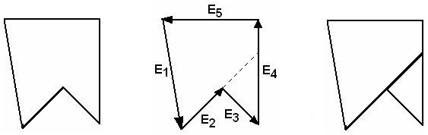
(a) (b) (c)

Figure 10 - Splitting a Concave Polygon into Convex Polygons

Representing Polygons

Polygons, and in particular convex polygons, are the most common type of primitive in 3-D graphics because they are used to represent polygonal meshes such as those shown in Figure 7. But how can polygonal meshes be represented? A common technique is to use tables of data. These tables can be of two different types:
- Geometric tables: These store information about the geometry of the polygonal mesh, i.e. what are the shapes/positions of the polygons?
- Attribute tables: These store information about the appearance of the polygonal mesh, i.e. what colour is it, is it opaque or transparent, etc. This information can be specified for each polygon individually or for the mesh as a whole.

Figure 11 shows a simple example of a geometric table. We can see that there are three tables: a vertex table, an edge table and a surface-facet table. The edge table has pointers into the vertex table to indicate which vertices comprise the edge. Similarly the surface-facet table has pointers into the edge table. This is a compact representation for a polygonal mesh, because each vertex’s coordinates are only stored once, in the vertex table, and also information about each edge is only stored once.

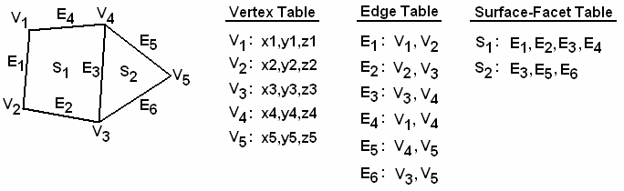

Figure 11 - A Geometric Table for Representing Polygons

Polygon Front and Back Faces

Most polygons are part of a 3-D polygonal mesh, which are often enclosed (solid) objects. Therefore when storing polygon information we need to know which face of the polygon is facing outward from the object. Every polygon has two faces: the front-face and the back-face. The front-face of a polygon is defined as the one that points outward from the object, whereas the back-face points towards the object interior.

Often in graphics we need to decide if a given point is on one side of a polygon or the other. For example, if we know the position of the virtual camera we may want to decide if the camera is looking at the front-face or the back-face of the polygon. (It can be more efficient for graphics packages not to render back-faces.)

We can make this calculation using the standard equation of a plane:

Ax + By + Cz + D = 0 …………………………………………………… (30)

Given at least three coplanar points (e.g. polygon vertices) we can always calculate the values of the coefficients A, B, C, and D for a plane. Now, for any given point (x,y,z):
- If Ax + By + Cz + D = 0, the point is on the plane.
- If Ax + By + Cz + D < 0, the point is behind the plane.
- If Ax + By + Cz + D > 0, the point is in front of the plane.

Polygon Normal Vectors

Polygon front-faces are usually identified using normal vectors. A normal vector is a vector that is perpendicular to the plane of the polygon and which points away from front face (see Figure 12).

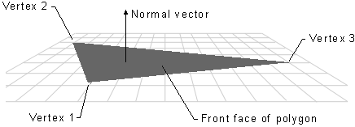

Figure 12 - The Normal Vector of a Polygon

Computing Normal Vectors

In graphics packages, we can either specify the normal vectors ourselves, or get the package to compute them automatically. How will a graphics package compute normal vectors automatically?

The simplest approach is to use the cross-product of adjacent edge vectors in the polygon boundary. Recall that the result of a cross-product is a vector that is perpendicular to the two vectors. Consider Figure 13. Here we can see three vertices of a polygon: V₁, V₂ and V₃. These form the two adjacent edge vectors E₁ and E₂:

E₁ = (1,0,0)
E₂ = (0,1,0)

Now, using Eq. (29) we can compute the surface normal , where 0 ≤ θ ≤ 180º, and the direction of is determined by the right-hand rule. This will give a vector that is perpendicular to the plane of the polygon. In this example, 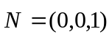.

Notice that if we consider the edge vectors to go the other way round the boundary (i.e. clockwise instead of anti-clockwise) then the normal vector would point in the other direction. This is the reason why in most graphics packages it is important which order we specify our polygon vertices in: specifying them in an anti-clockwise direction will make the normal vector point towards us, whereas specifying them in a clockwise direction will make it point away from us.

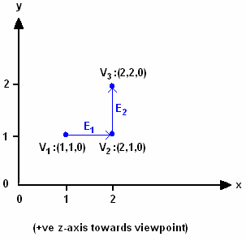

Figure 13 - Computing Surface Normals Using a Cross-Product of Adjacent Edges

OpenGL Fill-Area Routines

OpenGL provides a variety of routines to draw fill-area polygons. In all cases these polygons must be convex. In most cases the vertices should be specified in an anti-clockwise direction when viewing the polygon from outside the object, i.e. if you want the front-face to point towards you. The default fill-style is solid, in a colour determined by the current colour settings.

In all, there are seven different ways to draw polygons in OpenGL:
- glRect*
- Six different symbolic constants for use with glBegin … glEnd
We will now consider each of these techniques in turn.

glRect*

Two-dimensional rectangles can also be drawn using some of the other techniques described below, but because drawing rectangles in 2-D is a common task OpenGL provides the glRect* routine especially for this purpose (glRect* is more efficient for 2-D graphics than the other alternatives). The basic format of the routine is:

glRect* (x1, y1, x2, y2)

where (x1,y1) and (x2,y2) define opposite corners of the rectangle. Actually when we call the glRect* routine, OpenGL will construct a polygon with vertices defined in the following order:

(x1,y1), (x2,y1), (x2,y2), (x1,y2)

For example, Figure 14 shows an example of executing the following call to glRecti:

glRecti(200,100,50,250);

(The black crosses are only shown for the purpose of illustrating where the opposing corners of the rectangle are.)

In 2-D graphics we don’t need to worry about front and back faces – both faces will be displayed. But if we use glRect* in 3-D graphics we must be careful. For example, in the above example we actually specified the vertices in a clockwise order. This would mean that the back-face would be facing toward the camera. To get an anti-clockwise order (and the front-face pointing towards the camera), we must specify the bottom-left and top-right corners in the call to glRect*.

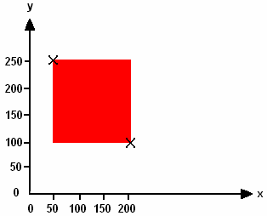

Figure 14 - Drawing a 2-D Rectangle with the OpenGL routine glRect*

GL_POLYGON

The GL_POLYGON symbolic constant defines a single convex polygon. Like all of the following techniques for drawing fill-area primitives it should be used as the argument to the glBegin routine. For example, the code shown below will draw the shape shown in Figure 15. Notice that the vertices of the polygon are specified in anti-clockwise order.

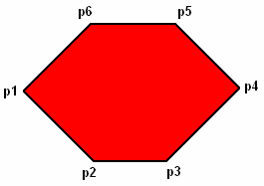
glBegin(GL_POLYGON);
glVertex2iv(p1);
glVertex2iv(p2);
glVertex2iv(p3);
glVertex2iv(p4);
glVertex2iv(p5);
glVertex2iv(p6);
glEnd();

Figure 15 - A Polygon Drawn Using the GL_POLYGON OpenGL Primitive
GL_TRIANGLES

The GL_TRIANGLES symbolic constant causes the glBegin … glEnd pair to treat the vertex list as groups of three 3 vertices, each of which defines a triangle. The vertices of each triangle must be specified in anti-clockwise order. Figure 16 illustrates the use of the GL_TRIANGLES primitive.
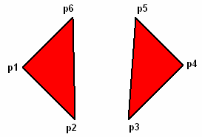

glBegin(GL_TRIANGLES);
glVertex2iv(p1);
glVertex2iv(p2);
glVertex2iv(p6);
glVertex2iv(p3);
glVertex2iv(p4);
glVertex2iv(p5);
glEnd();

Figure 16 - Triangles Drawn Using the GL_TRIANGLES OpenGL Primitive

GL_TRIANGLE_STRIP

To form polygonal meshes it is often convenient to define a number of triangles using a single glBegin … glEnd pair. The GL_TRIANGLE_STRIP primitive enables us to define a strip of connected triangles. The vertices of the first triangle only must be specified in anti-clockwise order. Figure 17 illustrates the use of GL_TRIANGLE_STRIP.

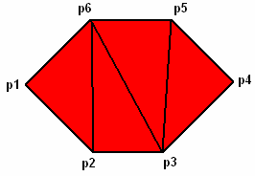
glBegin(GL_TRIANGLE_STRIP);
glVertex2iv(p1);
glVertex2iv(p2);
glVertex2iv(p6);
glVertex2iv(p3);
glVertex2iv(p5);
glVertex2iv(p4);
glEnd();
Figure 17 - Triangles Drawn Using the GL_TRIANGLE_STRIP OpenGL Primitive

GL_TRIANGLE_FAN

GL_TRIANGLE_FAN is similar to GL_TRIANGLE_STRIP, in that it allows us to define a number of triangles using a single glBegin … glEnd command. In this case, we can define a ‘fan’ of triangles emanating from a single point. The first point of the first triangle is the source of the fan, and the vertices of this triangle must be specified in an anti-clockwise direction. In addition, the fan of triangles must also be defined in an anti-clockwise direction. See Figure 18 for an example of the use of GL_TRIANGLE_FAN.

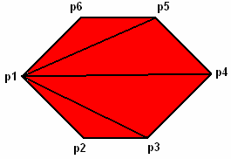
glBegin(GL_TRIANGLE_FAN);
Figure 18 - Triangles Drawn Using the GL_TRIANGLE_FAN OpenGL Primitive
glVertex2iv(p1);
glVertex2iv(p2);
glVertex2iv(p3);
glVertex2iv(p4);
glVertex2iv(p5);
glVertex2iv(p6);
glEnd();
GL_QUADS

Using the GL_QUADS primitive, the vertex list is treated as groups of four vertices, each of which forms a quadrilateral. If the number of vertices specified is not a multiple of four, then the extra vertices are ignored. The vertices for each quadrilateral must be defined in an anti-clockwise direction. See Figure 19 for an example of GL_QUADS.
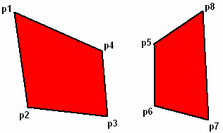
glBegin(GL_QUADS);
glVertex2iv(p1);
glVertex2iv(p2);
glVertex2iv(p3);
glVertex2iv(p4);
glVertex2iv(p5);
glVertex2iv(p6);
glVertex2iv(p7);
glVertex2iv(p8);
glEnd();
Figure 19 - Quadrilaterals Drawn Using the GL_QUADS OpenGL Primitive

GL_QUAD_STRIP

In the same way that GL_TRIANGLE_STRIP allowed us to define a strip of connected triangles, GL_QUAD_STRIP allows us to define a strip of quadrilaterals. The first four vertices form the first quadrilateral, and each subsequent pair of vertices is combined with the two before them to form another quadrilateral. The vertices of the first quadrilateral must be specified in an anti-clockwise direction. Figure 20 illustrates the use of GL_QUAD_STRIP.

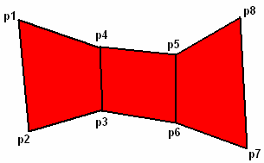
Figure 20 - Quadrilaterals Drawn Using the GL_QUAD_STRIP OpenGL Primitive
glBegin(GL_QUAD_STRIP);
glVertex2iv(p1);
glVertex2iv(p2);
glVertex2iv(p3);
glVertex2iv(p4);
glVertex2iv(p5);
glVertex2iv(p6);
glVertex2iv(p7);
glVertex2iv(p8);
glEnd();

Character Primitives

The final type of graphics primitive we will consider is the character primitive. Character primitives can be used to display text characters. Before we examine how to display characters in OpenGL, let us consider some basic concepts about text characters.

We can identify two different types of representation for characters: bitmap and stroke (or outline) representations. Using a bitmap representation (or font), characters are stored as a grid of pixel values (see Figure 21(a)). This is a simple representation that allows fast rendering of the character. However, such representations are not easily scalable: if we want to draw a larger version of a character defined using a bitmap we will get an aliasing effect (the edges of the characters will appear jagged due to the low resolution). Similarly, we cannot easily generate bold or italic versions of the character. For this reason, when using bitmap fonts we normally need to store multiple fonts to represent the characters in different sizes/styles etc.

An alternative representation to bitmaps is the stroke, or outline, representation (see Figure 21(b)). Using stroke representations characters are stored using line or curve primitives. To draw the character we must convert these primitives into pixel values on the display. As such, they are much more easily scalable: to generate a larger version of the character we just multiply the coordinates of the line/curve primitives by some scaling factor. Bold and italic characters can be generated using a similar approach. The disadvantage of stroke fonts is that they take longer to draw than bitmap fonts.

We can also divide character primitives into serif and sans-serif fonts. Sans-serif fonts have no accents on the characters, whereas serif fonts do have accents. For example, as shown below, Arial and Verdana fonts are examples of sans-serif fonts whereas Times-Roman and Garamond are serif fonts:
Arial is a sans-serif font
Verdana is a sans-serif font
Times Roman is a serif font
Garamond is a serif font
Finally, we can categorise fonts as either monospace or proportional fonts. Characters drawn using a monospace font will always take up the same width on the display, regardless of which character is being drawn. With proportional fonts, the width used on the display will be proportional to the actual width of the character, e.g. the letter ‘i’ will take up less width than the letter ‘w’. As shown below, Courier is an example of a monospace font whereas Times-Roman and Arial are examples of proportional fonts:

Courier is a monospace font
Times-Roman is a proportional font
Arial is a proportional font

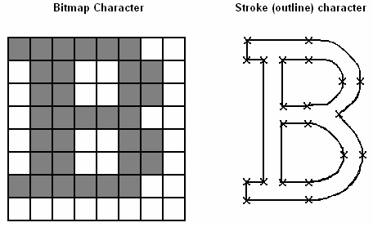
(a) (b)

Figure 21 - Bitmap and Stroke Character Primitives

OpenGL Character Primitive Routines

OpenGL on its own does not contain any routines dedicated to drawing text characters. However, the glut library does contain two different routines for drawing individual characters (not strings). Before drawing any character, we must first set the raster position, i.e. where will the character be drawn. We need to do this only once for each sequence of characters. After each character is drawn the raster position will be automatically updated ready for drawing the next character. To set the raster position we use the glRasterPos2i routine. For example,

glRasterPos2i(x, y)
positions the raster at coordinate location (x,y).

Next, we can display our characters. The routine we use to do this will depend on whether we want to draw a bitmap or stroke character. For bitmap characters we can write, for example,
glutBitmapCharacter(GLUT_BITMAP_9_BY_15, ‘a’);
This will draw the character ‘a’ in a monospace bitmap font with width 9 and height 15 pixels. There are a number of alternative symbolic constants that we can use in place of GLUT_BITMAP_9_BY_15 to specify different types of bitmap font. For example,
- GLUT_BITMAP_8_BY_13
- GLUT_BITMAP_9_BY_15
We can specify proportional bitmap fonts using the following symbolic constants:
- GLUT_BITMAP_TIMES_ROMAN_10
- GLUT_BITMAP_HELVETICA_10
Here, the number represents the height of the font.
Alternatively, we can use stroke fonts using the glutStrokeCharacter routine. For example,
glutStrokeCharacter(GLUT_STROKE_ROMAN, ‘a’);

This will draw the letter ‘a’ using the Roman stroke font, which is a proportional font. We can specify a monospace stroke font using the following symbolic constant:
- GLUT_STROKE_MONO_ROMAN

